Kroger Organization Code: WE056
Please take a moment and associate your Kroger card to The Roanoke Valley Governors School.
- Register online: krogercommunityrewards.com

- Click on Sign In or Create an Account (if you already have an account with Kroger, please select Sign In (have your Kroger Card Readily Available if you do not have an online account setup)
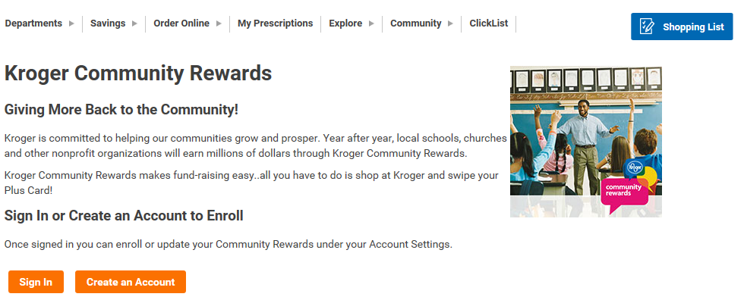

- After signing in, select My Account from the top right corner
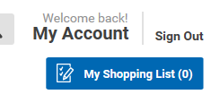

- Scroll down to Community Rewards and select “Enroll”

- Enter our Organization Number (WE056) or the name of the school and “Search”

- Select Roanoke Valley Governors School WE056 and “Enroll”
